Dashboard screenshots
- Landing page
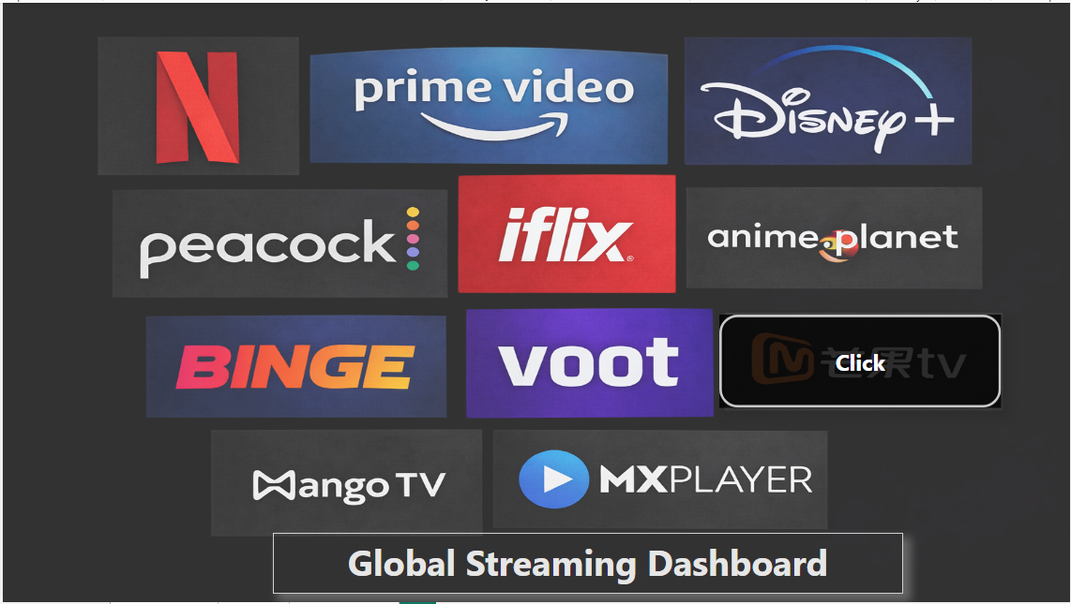

1] On clicking any logo, the dashboard navigates to the second page and displays the data for that service
2] on clicking the click button it will take you to the service details page
